Standing Committee on Legislation - inquiry into the Mining Legislation Amendment Bill 2015

SUBMISSION TITLE
COSTLY LEGISLATIVE SOLUTIONS TO NON-EXISTANT ENVIRONMENTAL PROBLEMS

Submission by
Dr Robert Keith Fagan:
5 Allsop Close Kalgoorlie, W.A. 6430
Mob: 0458532360
Email: robertfagan345@gmail.com
Dr Fagan is a retired geologist, former senior lecturer in exploration geology, geochemistry including environmental geochemistry at the Western Australian School of Mines until retirement in 2011. An active and current prospector and tenement holder for the last 30 years in WA. An active member of the Amalgamated Prospectors & Leaseholders Association (APLA) and on the APLA executive for most of the last 15 years, and a recent Vice President. Active member of the Goldfields First group of concerned prospectors and small business operators in the Goldfields.
General background to this submission
The purpose of this submission is to highlight the pointlessness of the Department of Mines and Resources (DMP), insistence of extending draconian environmental conditions over ground, where by on their own admission, there is a 97% environmental compliance rate (a near perfect performance).
The proposed environmental provisions contained within the Mining Act Amendments legislation 2015, will have serious unintended adverse economic and compliance consequences for the smaller professional operator while achieving no worthwhile benefit.
The case supporting this submission
By the DMP’s own admission (see below) there is a 97% environmental compliance rate (a near perfect performance) for the mining industry. It is difficult therefore to imagine that any additional costly, onerous compliance requirements, documentation, reporting and/or performance conditions are going to achieve any additional environmental benefit (at best only an additional 3% is achievable).
The “law of diminishing returns” states that incremental improvement is possible beyond this level only at exorbitant cost and effort, which far exceed the benefit gained. In the case of professional prospectors and small miners, with minimal ground disturbing activities over very small areas, the benefits to be gained would be insignificant. In other words it is a completely wasted exercise, involving substantial cost, requiring an inordinate effort, for virtually no material gain.
Supporting evidence
An extract from the DMP Budget Papers 2015 – Page 533.

Conclusion
In this instance such draconian environmental measures as proposed will be entirely futile and any significant effort or expenditure a complete waste. If it is not broke (which in this case it demonstrably isn’t), don’t fix it, and certainly don’t mandate futile processes to address it in legislation. This is particularly the case for the small miner where the environmental footprint is small, but may very well also apply to many larger mining operations which are also registering above 95% environmental compliance.
In the Mining Amendments Legislation 2015, the DMP is apparently trying to solve, by its own admission, a non-existent problem with a substantial slew of complicated, onerous and largely unnecessary legislation.

Signed 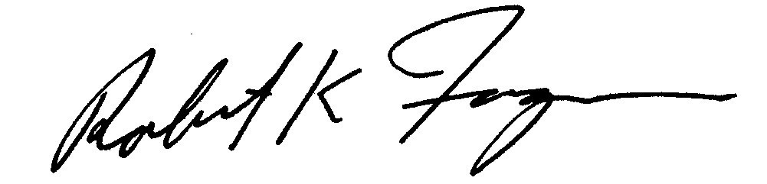 . Date 20/3/2016 .
Robert K. Fagan

Lodging your submission . Email: submissions can be emailed to the email address below. If you email your submission, you need to affix an electronic signature.
Submissions must be lodged with the Committee by 4.00 pm on the 24th March. Request for all or part of the submission to be kept private must be made at the time of submission. When making their submission, interested parties may also express an interest in being heard in person.

Contact Details
Phone Number: |  | 08 9222 7404
Fax Number: |  | 08 9222 7805
Email Address: |  | lclc@parliament.wa.gov.au
Postal Address
Mr David Driscoll
Parliamentary Officer (Committees)
Standing Committee on Legislation
GPO: Box A11
Perth WA 6837

